FitBuddy: AI-Powered Fitness Plan Generator
Project Presentation Document
Project | FitBuddy: AI-Powered Fitness Plan Generator
Domain | Generative AI, web application development
Presented by | Dharanipriya J, Askar A, Fasil Ahammed R N , Muppidathi Selvaraj K, Thanyaa Shree M L
Institution | Sri Krishna Adithya College of Arts and Science
Live application | https://fitbuddy-u8r0.onrender.com/
Source code | https://github.com/Dharanipriya-J/FitBuddy

Table of Contents
No. | Chapter / Section | Page
1 | Introduction | 3
2 | Problem Statement | 3
3 | Objectives, Scope and Features | 4
4 | Users and Usage Scenarios | 5
5 | Technology Stack | 5
6 | System Architecture | 6
7 | Project Structure | 8
8 | Implementation Details | 9
9 | API and Route Reference | 11
10 | Application Walkthrough | 12
11 | Testing and Validation | 15
12 | Deployment | 16
13 | Design Decisions | 17
14 | Challenges and Solutions | 17
15 | Limitations and Responsible Use | 18
16 | Future Scope | 18
17 | Conclusion | 19
 | References | 19
 | Appendix A: Code Listings | 19
 | Appendix B: Glossary | 21

1 Introduction
FitBuddy is a web application that builds a personal workout plan with Generative AI. A user opens the site and fills in a short form with a name, a user ID, age, weight, a fitness goal and a workout intensity. FitBuddy validates these details and sends them to Google Gemini, which returns a structured 7-day plan with a warm-up, main workout and cooldown for every day. A second, shorter request returns one nutrition tip for the same goal. Both appear on a result page, and the plan is saved in a database.
A plan is rarely perfect the first time, so FitBuddy includes a feedback step. Under the result, the user enters their user ID and a comment such as "Add more rest days please". FitBuddy sends the current plan and the comment back to Gemini, receives a complete updated plan, and shows it with a message and a link to view the original. A coach view lists every user together with the original and the updated plan, and lets the coach delete a user.
The application is written in Python. FastAPI provides the web server and the JSON API, Jinja2 renders the HTML pages, SQLAlchemy with SQLite stores the data, Pydantic validates every request, and the google-genai SDK connects to Gemini. The AI layer is built to keep working when a model is retired or busy: it tries a chain of fallback models, remembers the one that worked, and uses a built-in tip if the tip request fails.
Project in one line
Enter a few personal details, get a Gemini-written 7-day workout plan and nutrition tip, then ask for changes in plain words and receive an updated plan, all stored in a database.

1.1 Key facts
Item | Detail
Type of application | Browser-based web app in Python with server-rendered pages, a JSON API and automatic Swagger documentation
AI service | Google Gemini through the google-genai SDK; workout model gemini-3.6-flash and tip model gemini-3.5-flash-lite by default, with a fallback chain
Input fields | Name, user ID (whole number), age (10 to 100), weight (above 20 kg, up to 400 kg), fitness goal (free text), workout intensity (low, medium, high)
Outputs | 7-day workout plan, one nutrition tip, updated plan based on feedback
Database | SQLite file fitbuddy.db with two tables, users and plans
Coach view | Page at /view-all-users that lists all users with original and updated plans and a Delete button
Configuration | API key and optional model names are read from a .env file

2 Problem Statement
Many beginners want to start exercising but do not know where to begin. Plans found online are written for an average person and ignore the reader's age, body weight, goal and the effort they are ready to put in. A personal trainer solves this, but regular sessions are costly and not available to every student. Even people who start a routine often stop because it does not fit their week, and they have no easy way to change it.
Three difficulties come up again and again:
- Personalisation. A plan for an 18-year-old who wants to lose weight should look different from a plan for a 25-year-old who wants to gain weight. A fixed template cannot adapt to that.
- Adjustment. A plan that is too hard, too easy or has too few rest days must be changeable. Many tools give a plan once and stop.
- Continuity. A plan that disappears when the page is closed is hard to follow. Users and coaches need the plan saved and available later.
Large language models are well suited to this problem. They can turn a few facts about a person into a readable weekly schedule, and they can rewrite that schedule when the person explains what to change. FitBuddy wraps this ability in a complete service: validated input, a fixed plan format, storage of every plan and a simple way to revise it.

2.1 What FitBuddy is not
FitBuddy gives general fitness suggestions. It is not a medical service and it does not diagnose, treat or replace advice from a doctor, dietitian or qualified trainer. The workout prompt asks Gemini to end every plan with notes that include consulting a doctor before starting, and the plans shown in the walkthrough do so. Section 15 returns to this point.

3 Objectives, Scope and Features

3.1 Objectives
- Collect basic user details through a simple form and validate them before they are used.
- Use Google Gemini to generate a structured 7-day workout plan that matches the user's goal, intensity, age and weight.
- Generate a short nutrition tip for the user's goal, with a built-in tip as a backup.
- Let users send feedback and receive a complete updated plan, while keeping the original plan.
- Store users and plans in a database and offer a coach view with a delete option.
- Provide a documented JSON API (Swagger at /docs) beside the web pages.
- Keep the AI layer reliable when a Gemini model is unavailable or retired.

3.2 Scope
In scope | Out of scope
Personalised 7-day workout plans for any typed goal and three intensity levels | Medical advice, diagnosis or treatment
One nutrition tip per plan, with a static fallback | Meal plans, calorie counting or supplement advice
Feedback step that regenerates the whole plan | Progress tracking, charts or workout logging
SQLite storage, coach view and user deletion | User accounts, passwords and login
JSON API with automatic Swagger documentation | Mobile app, wearables or exercise videos

3.3 Features delivered
The table maps each feature to the part of the code that delivers it.
No. | Feature | Where and how it is delivered
1 | User profile input | templates/index.html form, route POST /generate-workout, model UserInput in schemas.py
2 | AI-generated 7-day plan | generate_workout_gemini() in gemini_generator.py
3 | AI-generated nutrition tip | generate_nutrition_tip_with_flash() in gemini_flash_generator.py, with get_fallback_tip() in nutrition.py as backup
4 | Feedback-based update | update_workout_plan() in updated_plan.py, route POST /submit-feedback
5 | Model fallback and discovery | generate_text() in gemini_generator.py tries a chain of models, then lists the models the key can use
6 | SQLite database | User and WorkoutPlan models and helper functions in database.py
7 | Coach view and deletion | Routes GET /view-all-users and POST /delete-user/{user_id}, template all_users.html
8 | JSON API and Swagger | Routes in routes.py under "JSON API"; documentation generated by FastAPI at /docs

4 Users and Usage Scenarios
FitBuddy is aimed at beginners who want a sensible starting routine, and at coaches who want to see what their trainees received. The scenarios below use the example users that appear in the application screenshots.
Scenario | User | What they enter | What they receive
1. Lose weight | Anu, a college student | Age 18, 50 kg, goal Weight loss, intensity High | A high-intensity week (full body HIIT, lower body, active recovery, tabata) with a rest day and a nutrition tip about filling half the plate with vegetables
2. Gain weight | Rahul, a young adult | Age 18, 40 kg, goal Weight gain, intensity High | A strength-focused week that starts with an upper body day
3. Adjust the plan | Anu, after reading her plan | Feedback: "Add more rest days please" | An updated 7-day plan in which Day 3, Day 6 and Day 7 are rest or recovery days

4.1 Who benefits
- Beginners and students who need a structured, low-cost starting point.
- Coaches and mentors who use the coach view to review every user's original and updated plan.
- Regular exercisers who want to adapt a plan to their own week by typing a short comment.

5 Technology Stack
Layer | Technology | Role in FitBuddy
Language | Python 3 | All backend and AI logic
Web framework | FastAPI with Uvicorn | Page routes, form handling, JSON endpoints and Swagger documentation
Templates | Jinja2, HTML, CSS | Home page, result page and coach view with a dark theme and a gym background image
AI | Google Gemini via google-genai | Workout plan, nutrition tip and updated plan
Database | SQLite, SQLAlchemy 2 | Stores users, original plans and updated plans
Validation | Pydantic | UserInput, FeedbackRequest and WorkoutRequest models
Configuration | python-dotenv | Loads GOOGLE_API_KEY and optional model names from .env
Form support | python-multipart | Lets FastAPI read HTML form submissions

5.1 Why these choices
Google Gemini. The Flash models are designed for quick, low-cost answers, which suits a page where the user waits for a result. A weekly plan is structured text, so following a fixed format matters more than deep reasoning.
FastAPI. It validates input, serves both HTML pages and JSON from one small application, and creates interactive API documentation without extra work.
Jinja2 with plain HTML and CSS. Server-rendered pages need no JavaScript framework, so the frontend stays small and the whole project runs as one service.
SQLite with SQLAlchemy. SQLite needs no separate database server, so setup is a single command. Because SQLAlchemy sits on top, moving to PostgreSQL later would mainly mean changing the database URL in database.py.

6 System Architecture
FitBuddy keeps the web layer, the AI layer and the data layer apart. The routes receive requests, the AI modules talk to Gemini, and the database module stores results. Figure 1 shows how the parts connect.

6.1 Components
Component | Responsibility
Entry point (main.py) | Loads .env, creates the FastAPI app, creates the tables at start-up through a lifespan handler, mounts /static and includes the router
Routes (routes.py) | All page and API routes; validates input, calls the AI functions and the database helpers and renders the templates
Schemas (schemas.py) | UserInput, FeedbackRequest and WorkoutRequest Pydantic models with field limits
Database (database.py) | SQLAlchemy engine, session factory, User and WorkoutPlan models and the save, update, get and delete helpers
Plan generator (gemini_generator.py) | Gemini client, model fallback chain, text cleaning and the workout plan prompt
Tip generator (gemini_flash_generator.py) | Nutrition tip prompt, with a fallback to nutrition.py when Gemini fails
Plan updater (updated_plan.py) | Prompt that revises the current plan using the user's feedback
Templates and static files | index.html, result.html, all_users.html and the background image gym-bg.jpg

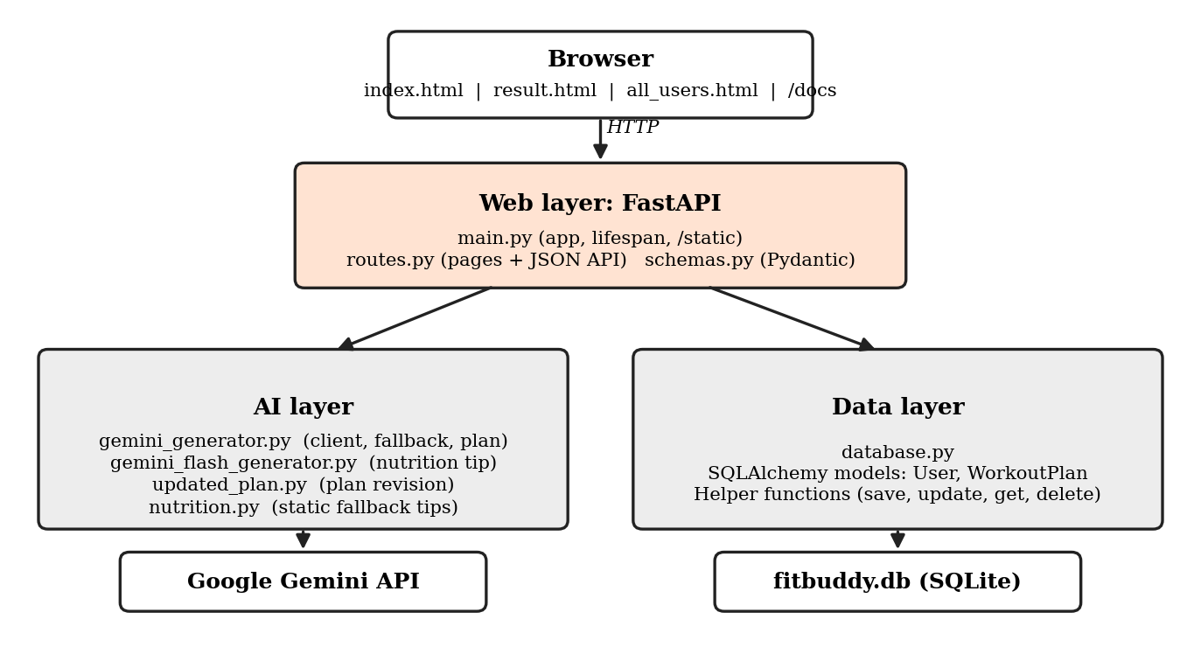
Figure 1: FitBuddy layered architecture

6.2 Request lifecycle
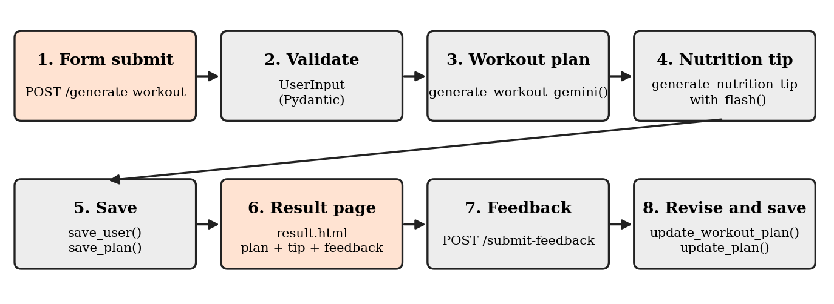
Figure 2: From form input to result page and feedback
- The user fills in the form on the home page and clicks Generate plan.
- The browser sends the fields to POST /generate-workout. The route builds a UserInput object, which checks every field. An error returns the home page with a message.
- The route calls generate_workout_gemini(). If Gemini cannot produce a plan, the home page is shown again with an error message and nothing is saved.
- The route calls generate_nutrition_tip_with_flash() for the nutrition tip. If that call fails, a built-in tip is used.
- save_user() creates the user or updates the existing one, and save_plan() stores the new plan, replacing any earlier plan for that user.
- result.html shows the profile strip, the 7-day plan, the nutrition tip and the "Change your plan" form.
- A feedback submission goes to POST /submit-feedback. The route finds the user's current plan, asks Gemini for an updated plan, stores it with update_plan() and shows it with the original available under "View your original plan".

6.3 Data model
Two tables hold all data. Each user has at most one plan record. The updated_plan column stays empty until the user submits feedback, and generating a new plan for the same user ID clears it again.
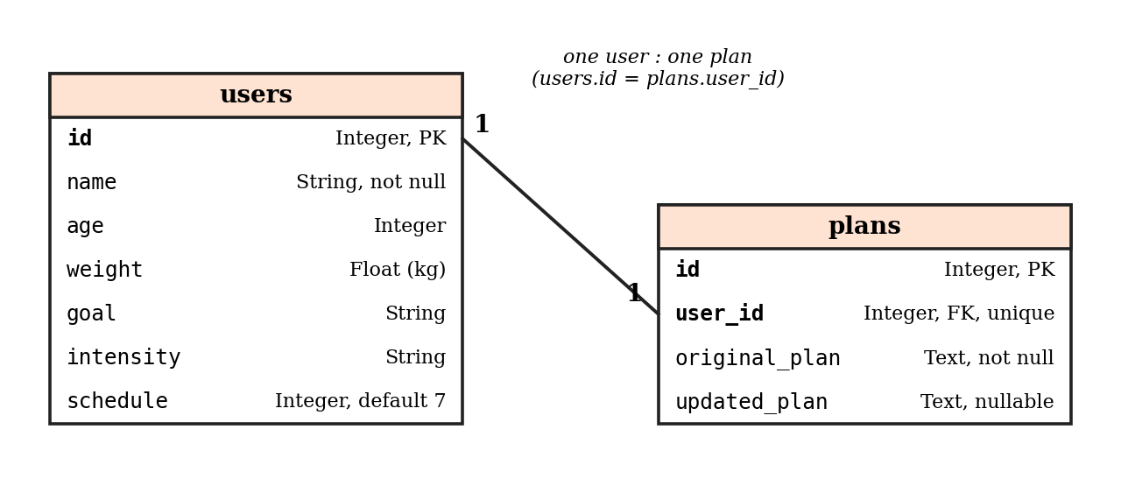
Figure 3: Database tables and relationship

7 Project Structure
The project folder is small and flat. All Python modules sit together in the app folder, the pages are in app/templates, and the background image is in app/static/images. Figure 4 shows the folder as it appears in Visual Studio Code, and Listing 1 explains each item.
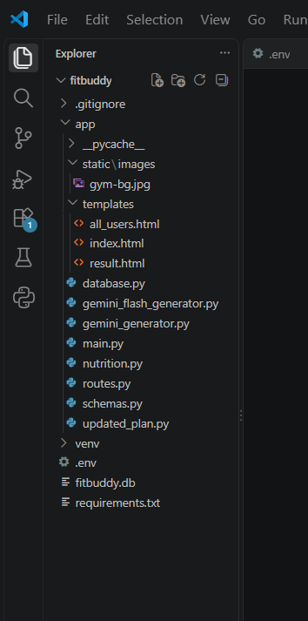  Figure 4: Project folder in VS Code | fitbuddy/  |-- .gitignore  |-- .env (API key, model names)  |-- fitbuddy.db (SQLite database)  |-- requirements.txt  |-- venv/ (virtual environment)  `-- app/  |-- main.py app + lifespan  |-- routes.py pages + JSON API  |-- schemas.py Pydantic models  |-- database.py models + helpers  |-- gemini_generator.py client + plan  |-- gemini_flash_generator.py nutrition tip  |-- updated_plan.py plan revision  |-- nutrition.py fallback tips  |-- templates/  | |-- index.html input form  | |-- result.html plan + tip  | `-- all_users.html coach view  |-- static/images/gym-bg.jpg  `-- __pycache__/ (auto-generated)  Listing 1: Project layout

File or folder | Purpose
app/main.py | Starts the application; run with uvicorn app.main:app --reload from the project root
app/routes.py | Every route, grouped as web pages and JSON API
app/schemas.py | Request validation models
app/database.py | Tables and database helper functions
app/gemini_generator.py | Shared Gemini client and the 7-day plan generator
app/gemini_flash_generator.py | Lightweight nutrition tip generator
app/updated_plan.py | Feedback-based plan revision
app/nutrition.py | Static tips used only when the Gemini call fails
app/templates/ | The three Jinja2 pages
app/static/images/ | gym-bg.jpg, the background of every page
.env | Holds the real API key; must not be committed to Git
fitbuddy.db | SQLite database, created automatically on first start
requirements.txt | fastapi, uvicorn, jinja2, sqlalchemy, python-multipart, google-genai, python-dotenv

Two details are worth noting. First, the AI code is split by purpose: the plan generator owns the Gemini client and the fallback logic, and the tip and update modules reuse it with their own prompts. Second, .env holds the real API key, so it belongs in .gitignore, and the venv folder and the database file normally stay out of Git as well.

8 Implementation Details

8.1 Configuration
Secrets and model names are read from environment variables. main.py and gemini_generator.py call load_dotenv(), so a .env file in the project root is enough. The API key is never written into the source code.
Setting | Purpose
GOOGLE_API_KEY | Gemini API key from Google AI Studio. GEMINI_API_KEY is accepted as an alternative name. A missing key, or a placeholder that starts with "your_", raises a clear error message
WORKOUT_MODEL | Optional. Preferred model for plans and updates (default gemini-3.6-flash)
TIP_MODEL | Optional. Preferred model for nutrition tips (default gemini-3.5-flash-lite)

8.2 AI layer

Shared client and fallback: gemini_generator.py
This module creates one cached genai.Client and exposes generate_text(prompt, role, preferred). The function builds a list of candidate models in this order: the model that last worked for the same role, the preferred model, and then a fixed list (gemini-3.6-flash, gemini-3.5-flash, gemini-3.5-flash-lite, gemini-flash-latest, gemini-2.5-flash). Each candidate is tried once. If every candidate fails, the function asks the API for the models the key can use, keeps the text-capable Flash models and tries those. An authentication error stops the process at once with a message to check the key, because trying more models cannot fix it. If nothing works, a GeminiError carries the last error message, shortened to 300 characters.
The helper clean_text() removes markdown symbols such as ** and # headings and turns "- " and "* " list markers into a bullet character, so the plan reads cleanly inside the page.

Workout plan: generate_workout_gemini()
The prompt asks Gemini to act as a professional fitness trainer and lists the goal, the intensity and, when available, age and weight. Each day must contain a warm-up of 5 to 10 minutes, a main workout with sets and reps, and a cooldown or recovery tip. Rest or active-recovery days are requested where suitable for the intensity. The prompt fixes a plain text format (Day 1 to Day 7) and ends with a short Notes section on form, progression and consulting a doctor before starting.

Nutrition tip: gemini_flash_generator.py
generate_nutrition_tip_with_flash(goal) asks for one practical tip in two sentences, using the lighter tip model. If Gemini raises a GeminiError, the function logs a warning and returns a stored tip from nutrition.py, chosen from the words in the goal (loss, gain or general). The result page therefore always shows a tip.

Plan update: updated_plan.py
update_workout_plan(original_plan, user_feedback) sends the current plan and the feedback together. Gemini is asked to revise the relevant parts, keep the same format and leave unchanged days as they are, and to return the complete plan in plain text. The user therefore receives a whole plan instead of a list of changes.

8.3 Validation: schemas.py
Field | Rule
user_id | Whole number greater than 0
username | 1 to 60 characters
age | Whole number from 10 to 100
weight | Greater than 20 and at most 400 (kg)
goal | 2 to 200 characters of free text (for example weight loss, muscle gain or flexibility)
intensity | low, medium or high; leading and trailing spaces and capital letters are ignored
feedback | 3 to 500 characters

8.4 Database: database.py
database.py defines the engine for fitbuddy.db in the project root, a session factory, the two models shown in Figure 3 and the helper functions used by the routes. init_db() creates the tables and runs once at start-up through the FastAPI lifespan handler, so the file is created automatically on first run. Each helper opens its own session and closes it in a finally block.
Helper | What it does
save_user() | Creates a user or updates the existing user with the same ID
save_plan() | Stores a new plan; for an existing user it replaces original_plan and clears updated_plan
update_plan() | Writes the updated plan text for the user
get_original_plan(), get_current_plan() | Return the original plan, or the updated plan when one exists
get_user(), get_all_users(), get_all_plans() | Read helpers for the result page and the coach view
delete_user() | Deletes the user's plan and then the user

8.5 Routes: routes.py
routes.py ties everything together. The /generate-workout route validates the form, generates the plan, generates the tip, saves the user and plan and renders result.html. The /submit-feedback route checks the user ID and feedback, finds the current plan, requests the update, saves it and renders the result page with a success message and the original plan. Errors are handled in two ways: validation problems return the home page with a message such as "Please check 'age': ...", and Gemini failures return a 502 status with the error text, so the application shows a message instead of crashing.

8.6 Frontend: templates
- index.html: the FitBuddy heading, a short introduction, the form with six fields (a dropdown for intensity) and a "Coach view: all users" link.
- result.html: a profile strip (name, user ID, age, weight, goal, intensity), the 7-day plan in a text block, the nutrition tip card and the "Change your plan" form. After an update it also shows a success message, the heading "Updated 7-day plan" and an expandable "View your original plan".
- all_users.html: a table with ID, name, age, weight, goal, intensity, original plan, updated plan and a Delete button for each user.
- All pages use a dark theme with an orange accent colour and the gym-bg.jpg background.

9 API and Route Reference
FastAPI generates interactive documentation at /docs, where every JSON route can be tried directly in the browser. The routes fall into two groups.

9.1 Web page routes
Method | Route | Description
GET | / | Home page with the profile form
POST | /generate-workout | Form fields: username, user_id, age, weight, goal, intensity. Validates, generates the plan and tip, saves them and shows the result page
POST | /submit-feedback | Form fields: user_id, feedback. Updates the user's plan and shows the result page
GET | /view-all-users | Coach view with every user, original plan and updated plan
POST | /delete-user/{user_id} | Deletes the user and the plan, then redirects to /view-all-users

9.2 JSON API routes
Method | Route | Description
POST | /generate-plan | JSON body with the UserInput fields. Generates and saves a plan and returns a message and workout_plan
POST | /generate-workout/gemini | JSON body with goal and intensity. Returns the model name and a workout_plan without saving
GET | /nutrition-tip?goal= | Returns the goal and a nutrition_tip
POST | /update-plan/{user_id} | JSON body with feedback. Returns the updated_plan; 404 if the user has no plan
GET | /docs | Swagger UI generated by FastAPI

Because the JSON routes use ordinary HTTP, they can be called from the command line. Listing 2 creates and saves a plan.
curl -X POST http://127.0.0.1:8000/generate-plan \
-H "Content-Type: application/json" \
-d "{\"user_id\": 101, \"username\": \"Asha\", \"age\": 19,
\"weight\": 60, \"goal\": \"general fitness\",
\"intensity\": \"medium\"}"
Listing 2: Example request to /generate-plan (returns JSON)

10 Application Walkthrough
This section follows one complete use of the application. All screenshots were taken from the running application.

10.1 Entering the details
The home page shows the FitBuddy heading and a card with the form. All six fields are required.
Field | Purpose | Allowed values
Name | Shown in the profile strip and in the coach view | 1 to 60 characters
User ID | Identifies the user; reusing it replaces that user's plan | Whole number above 0
Age | Helps Gemini choose suitable exercises | 10 to 100
Weight (kg) | Helps Gemini scale the plan | Above 20, up to 400
Fitness goal | Direction of the plan, typed freely | 2 to 200 characters, for example weight loss
Workout intensity | How hard the sessions should be | Low, Medium, High

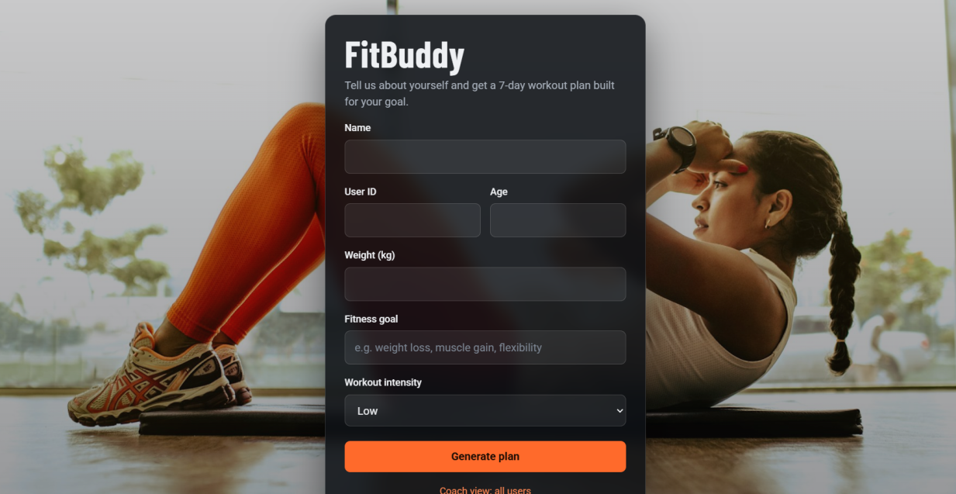
Figure 5: FitBuddy home page with the empty form
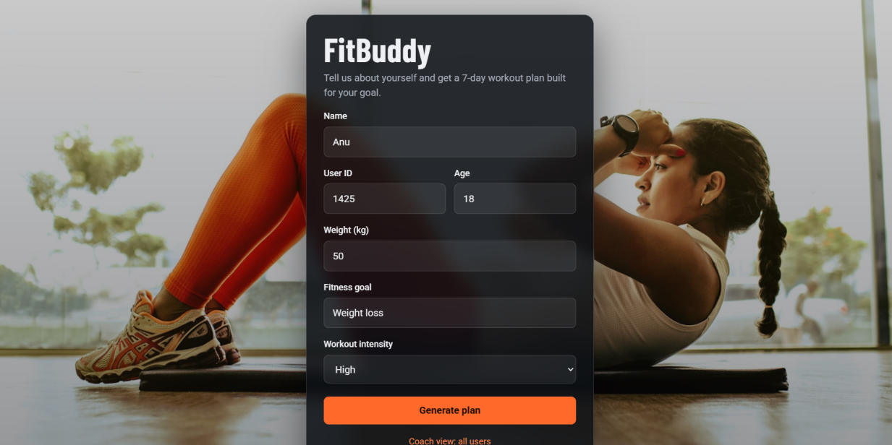
Figure 6: Form filled with example details (Anu, age 18, 50 kg, weight loss, high)

10.2 Generating and viewing the plan
Clicking Generate plan sends the form. Gemini needs a few seconds, so the page waits briefly. The result page shows the heading "Your workout plan", a strip with the user's details, the 7-day plan card with Gemini's output, and the Nutrition tip card. Figure 7 shows the top and the bottom of this page side by side. The plan text is written by Gemini and differs from run to run.
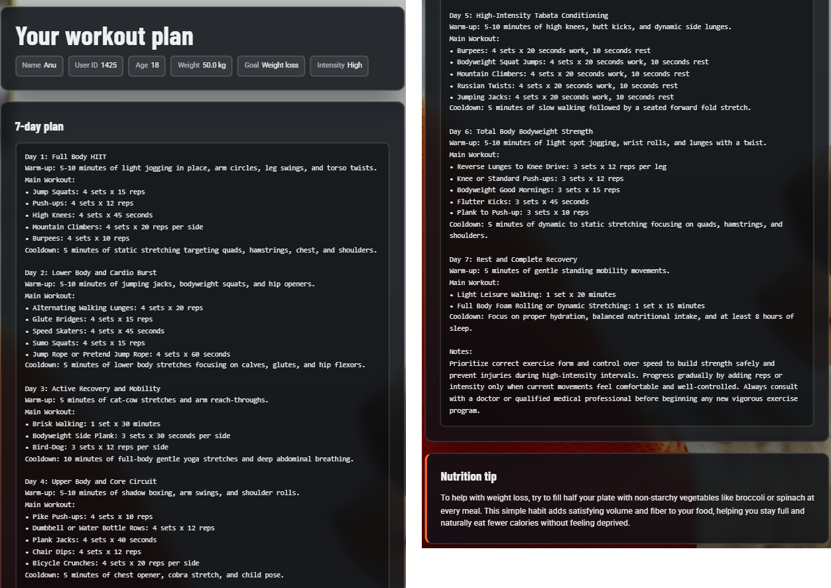
Figure 7: Result page with the 7-day plan (left) and the rest of the plan with the nutrition tip (right)

10.3 Improving the plan with feedback
At the bottom of the result page, the Change your plan card asks for the user ID and a short comment. Figure 8 shows the form with the feedback "Add more rest days please".
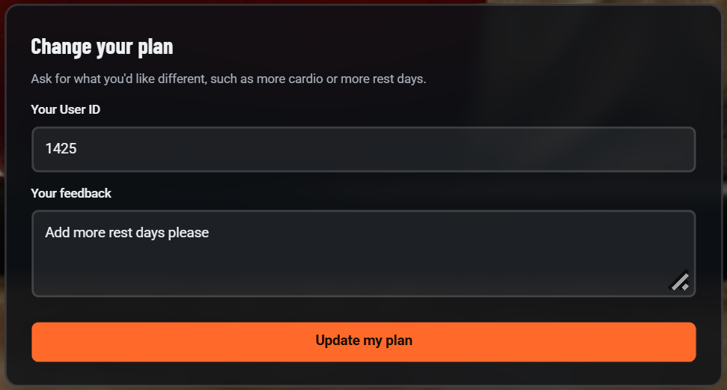
Figure 8: Feedback form on the result page
After Update my plan, the page shows the message "Your plan has been updated based on your feedback!" and the Updated 7-day plan. In Figure 9 the new plan has rest or recovery on Day 3, Day 6 and Day 7. A "View your original plan" link at the bottom opens the first version.
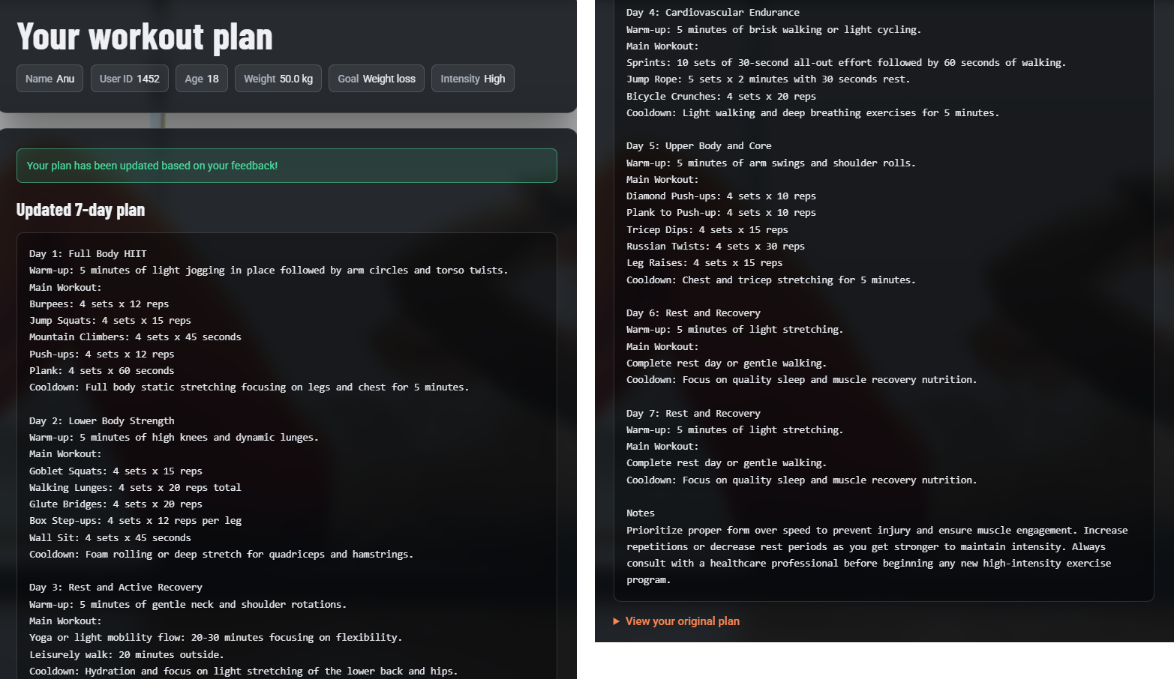
Figure 9: Updated 7-day plan after feedback (start on the left, end on the right)

10.4 Coach view
The Coach view: all users link opens /view-all-users. Each user is a row with the profile details, a scrollable box with the original plan, a box with the updated plan (or "Not updated") and a Delete button.
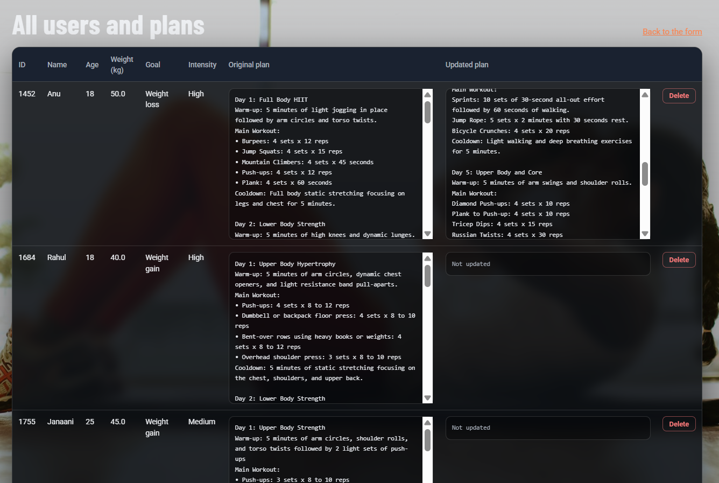
Figure 10: Coach view listing all users with original and updated plans

10.5 Structure of a generated plan
Part | Content
Day 1 to Day 7 | A title with the focus of the day, a warm-up, a main workout with sets and reps or durations, and a cooldown. Rest and active-recovery days appear where suitable
Notes | Two or three lines on correct form, gradual progression and consulting a doctor before starting
Nutrition tip | A separate card with one practical tip for the user's goal
Updated plan | The same Day 1 to Day 7 format, with the user's feedback applied

11 Testing and Validation

11.1 Built-in validation
Every form and JSON request passes through a Pydantic model before anything is saved or sent to Gemini. Out-of-range ages, a non-numeric user ID, a missing name, an unknown intensity or feedback that is too short are rejected. On the web pages the user sees a message that names the field, for example "Please check 'age': ...". The intensity dropdown also prevents invalid values in the browser.

11.2 Manual test cases
The checks below cover the main flows and the failure cases the application is designed to handle.
Check | What is verified | Expected result
Normal generation | Valid details for a new user | Plan and tip appear; rows are added to users and plans
Returning user | Same user ID with a new goal | User row is updated; the plan is replaced and any earlier update is cleared
Invalid age | Age 9 or 150 | Home page returns with a message about 'age'
Invalid user ID | User ID 0 or text | Home page returns with a message about 'user_id'
Feedback applied | Submit "Add more rest days please" | Updated plan appears with a success message; original is available
Unknown user | Feedback with an ID that has no plan | Message "No plan found for User ID ... Generate a plan first"
Short feedback | Feedback of one or two characters | Message asking for a user ID and a few words of feedback
Coach view and delete | Open /view-all-users and delete a user | User and plan disappear from the table
Missing API key | Start without GOOGLE_API_KEY | Clear error asking to add the key to .env
Model unavailable | Preferred model fails | Next model in the chain is tried; the working model is remembered
Tip failure | Tip request fails | A stored tip from nutrition.py is shown

11.3 API checks
- Open /docs and confirm that all JSON routes are listed and can be run.
- Call GET /nutrition-tip?goal=weight loss and confirm that a tip is returned.
- Call POST /update-plan/{user_id} for a user without a plan and confirm the 404 response.

12 Deployment

12.1 Running locally
Local setup needs Python 3.10 or newer, a virtual environment and a free Gemini API key from Google AI Studio.
- Create and activate a virtual environment (python -m venv venv, then venv\Scripts\activate on Windows).
- Install the dependencies with pip install -r requirements.txt.
- Create a file named .env in the project root and add the line GOOGLE_API_KEY=your key.
- From the project root, start the server with uvicorn app.main:app --reload.
- Open http://127.0.0.1:8000 for the application and http://127.0.0.1:8000/docs for Swagger.

12.2 Public hosting
The same project can run on any host that supports Python web services. The cover page links the hosted version on Render. A typical configuration is:
- Push the code to GitHub without the .env file.
- Create a web service on the host and connect the repository.
- Set the build command to pip install -r requirements.txt.
- Set the start command to uvicorn app.main:app --host 0.0.0.0 --port $PORT.
- Add GOOGLE_API_KEY (and optionally WORKOUT_MODEL and TIP_MODEL) as environment variables, then deploy.

Security note
The Gemini API key lives only in .env on the local computer and in the host's environment variables online. Keep .env, the venv folder and fitbuddy.db out of Git. The coach view and the delete button are not password protected, so a public deployment should add a login before real user data is stored.

On free hosting plans the disk is often temporary, so the SQLite file can be reset when the service restarts. For permanent storage, attach a persistent disk or change DATABASE_URL in database.py to a hosted database such as PostgreSQL.

13 Design Decisions
The code shows several deliberate design decisions. The table records each decision and the reason behind it.
Area | Decision in the code | Reason
AI modules | One shared client module, with separate prompt modules for the plan, the tip and the update | Each task needs its own format; the fallback logic is written once
Model handling | Models can be set in .env, and a fallback chain with automatic discovery is used | The app keeps working when Google retires or rotates models
Remembered model | The last model that worked for each role is tried first | Avoids repeating failed calls on later requests
Plan update | Send the current plan with the feedback and ask for the complete plan | The user gets a whole plan, not only a list of changes
Plan storage | One plan record per user holding the original and the latest update | Simple data model; the original stays visible next to the update
Tip fallback | Static tips in nutrition.py | The result page works even if the tip request fails
Text cleaning | clean_text() strips markdown symbols | Plans display cleanly in a plain text block
Interface | Server-rendered Jinja2 pages with plain CSS | Small, simple and easy to run as one service

14 Challenges and Solutions
The table lists the main problems the application is designed to handle and how the code handles each one.
Challenge | How it was handled
Retired or unavailable Gemini models | Moved model names to .env, added a fallback list and a last-resort search of the models the key can use
Invalid API key | Recognised authentication errors and stopped with a message that points to the key in .env
Markdown symbols in AI output | Asked Gemini for plain text and added clean_text() to remove any symbols that remain
Tip request failing | Added a static fallback tip so the result page always renders
Bad or incomplete input | Added Pydantic models with limits, and a message that names the faulty field
Same user submitting twice | Looked users up by ID and updated them instead of creating duplicates
Plan lost on regeneration | Kept the original and the update in separate columns and showed the original in an expandable section
Keeping secrets out of Git | Moved the API key to .env and kept the file out of version control

15 Limitations and Responsible Use
FitBuddy produces general fitness suggestions, and users must treat them that way. The main limitations are:
- Not medical advice. The plans are AI-generated and not reviewed by a doctor or certified trainer. People with injuries, pain or health conditions should consult a professional first, as the plan notes remind them.
- Model variability. Two runs with the same input can produce different plans, and Gemini may occasionally suggest exercises that do not suit a person.
- Limited personalisation. The form collects only age, weight, goal and intensity. Height, gender, available days, equipment and health conditions are not collected, and the plan is always 7 days long.
- Younger users. The form accepts ages from 10, but the prompts contain no extra safety rules for young users beyond the general advice to consult a doctor.
- No login. Users choose their own ID, so anyone who types an existing ID replaces that user's plan. The coach view and the delete button are open to anyone who knows the address.
- One revision stored. Only the original plan and the latest update are saved. Earlier updates are overwritten, and the feedback text itself is not stored.
- Tip not stored. The nutrition tip is generated again each time the result page is built and is not saved in the database.
- Dependence on an external service. Plan generation needs the Gemini API, whose speed, availability and limits are controlled by Google.
- Storage and testing. SQLite may be reset on free hosting platforms, and the project has no automated test suite, so testing is manual.
The workout prompt asks for notes on consulting a doctor, and this document states the limits openly. Presenting them honestly is a strength of the project rather than a weakness.

16 Future Scope
- User accounts and login. Replace the open coach view with authentication so each user sees only their own plan and a coach role can see everyone.
- Safer plans for young users. Add age-based rules to the prompts and a minimum age that matches the guidance.
- More personal details. Collect height, gender, available days per week, equipment and health notes, and pass them to the generator.
- Plan history. Keep every revision and the feedback that produced it, not only the latest update.
- Progress tracking. Let users mark workouts as done and show weekly progress charts.
- Better plan display. Show each day as a card and allow download as a PDF.
- Persistent database. Move to PostgreSQL for permanent hosted storage.
- Automated tests. Add a pytest suite with a mock Gemini client so the application can be tested without an API key.
- Multilingual support. Generate plans in regional languages such as Tamil.

17 Conclusion
FitBuddy shows that a focused use of Generative AI can give beginners a personal starting point for exercise. A user supplies six short inputs and receives a structured 7-day plan and a nutrition tip, can ask for changes in plain language and receives an updated plan. The system is built from clearly separated parts: a FastAPI web layer, validation with Pydantic, an AI layer around Google Gemini and a SQLite data layer.
Beyond the core feature, the project reflects sound engineering habits. It validates input, falls back to other models when one fails, keeps a backup nutrition tip, keeps secrets in .env, stores the original and the updated plan, and is honest about what a general fitness tool can and cannot promise. The structure leaves clear room to grow toward accounts, plan history and richer personalisation.

Live application | https://fitbuddy-ai-fitness-plan-generator-1-ivb8.onrender.com
Source code | https://github.com/lipikaramasamy/Vetri-Thiran-Payirrchi-Thittam.git

References
- FastAPI documentation: https://fastapi.tiangolo.com
- Jinja2 documentation: https://jinja.palletsprojects.com
- SQLAlchemy documentation: https://docs.sqlalchemy.org
- Pydantic documentation: https://docs.pydantic.dev
- Google Gemini API documentation: https://ai.google.dev/gemini-api/docs
- Google AI Studio (API keys): https://aistudio.google.com/apikey
- Uvicorn documentation: https://www.uvicorn.org

Appendix A: Code Listings
The following excerpts show the core code of the project.

A.1 Input validation (app/schemas.py)
Intensity = Literal["low", "medium", "high"]

class UserInput(BaseModel):
user_id: int = Field(..., gt=0)
username: str = Field(..., min_length=1, max_length=60)
age: int = Field(..., ge=10, le=100)
weight: float = Field(..., gt=20, le=400)
goal: str = Field(..., min_length=2, max_length=200)
intensity: Intensity

_norm = field_validator("intensity", mode="before")(_normalize_intensity)
Listing A1: UserInput model

A.2 Database models (app/database.py)
class User(Base):
__tablename__ = "users"
id = Column(Integer, primary_key=True, index=True)
name = Column(String, nullable=False)
age = Column(Integer)
weight = Column(Float)
goal = Column(String)
intensity = Column(String)
schedule = Column(Integer, default=7)

class WorkoutPlan(Base):
__tablename__ = "plans"
id = Column(Integer, primary_key=True, index=True)
user_id = Column(Integer, ForeignKey("users.id"), unique=True, nullable=False)
original_plan = Column(Text, nullable=False)
updated_plan = Column(Text, nullable=True)
Listing A2: User and WorkoutPlan models

A.3 Generate route (app/routes.py)
@router.post("/generate-workout", response_class=HTMLResponse)
def generate_workout(request, username=Form(...), user_id=Form(...), age=Form(...),
weight=Form(...), goal=Form(...), intensity=Form(...)):
try:
data = UserInput(username=username.strip(), user_id=user_id, age=age,
weight=weight, goal=goal.strip(), intensity=intensity)
except ValidationError as e:
return _index(request, _first_error(e), values, 400)
try:
plan = generate_workout_gemini({"goal": data.goal, "intensity": data.intensity,
"age": data.age, "weight": data.weight})
except GeminiError as e:
return _index(request, str(e), values, 502)
tip = generate_nutrition_tip_with_flash(data.goal)
save_user(data.user_id, data.username, data.age, data.weight,
data.goal, data.intensity)
save_plan(data.user_id, plan)
return _result(request, get_user(data.user_id), plan, tip)
Listing A3: /generate-workout route

A.4 Model fallback (app/gemini_generator.py)
def generate_text(prompt: str, role: str, preferred: str) -> str:
client = get_client()
candidates = []
for m in [_working_model.get(role), preferred, *FALLBACK_MODELS]:
if m and m not in candidates:
candidates.append(m)
for model in candidates:
try:
return attempt(model) # remembers the model that worked
except Exception as e:
if _is_auth_error(str(e)):
raise GeminiError("Your Gemini API key was rejected.") from e
for model in _discover_models(client): # last resort: ask the API
...
raise GeminiError("Gemini could not generate a response right now.")
Listing A4: Fallback chain (shortened)

A.5 Launch commands
pip install -r requirements.txt
uvicorn app.main:app --reload
Listing A5: Install and run

Appendix B: Glossary
Term | Meaning
Generative AI | AI models that create new content, such as text, from a prompt
Google Gemini | Google's family of large language models, accessed through an API
Prompt | The instruction text sent to the model; here it contains the user's details and the required plan format
SDK | Software development kit; the google-genai Python library used to call Gemini
Fallback model | A second model that is tried automatically when the first one fails
FastAPI | Python framework for web apps and REST APIs with automatic validation and documentation
Uvicorn | The server that runs a FastAPI application
Jinja2 | Template engine that fills HTML pages with data from Python
SQLAlchemy | Python library that maps classes to database tables
SQLite | A lightweight database stored in a single file
Pydantic | Library that validates data against a model class such as UserInput
Swagger UI | Interactive API documentation page generated at /docs

